  ChessProg  Architecture Documentation | Exposee  ChessProg is a modular chess engine used as a real-world example of software architecture. demonstrates how to design, evaluate, and document complex systems using arc42.  Ahmet Inci  Software Architecture

ChessProg is a modular chess engine used as a real-world example of software architecture. demonstrates how to design, evaluate, and document complex systems using arc42.
Ahmet Inci
Software Architecture

ChessProg is a modular chess engine used as a real-world example of software architecture. demonstrates how to design, evaluate, and document complex systems using arc42.
Ahmet Inci
Software Architecture

Inhalt

ChessProg 1
1. Introduction and Goals 1
1.1 Requirements Overview 1
What is ChessProg? 1
Essential Features 1
1.2 Quality Goals 2
1.3 Stakeholders 2
2. Constraints 3
2.1 Technical Constraints 3
2.2 Organizational Constraints 3
2.3 Conventions 4
3. Context 5
3.1 Business Context 5
3.2 Deployment Context 6
4. Solution Strategy 7
4.1 Introduction to the Strategy 7
4.2 Structure of ChessProg 8
4.4 The Connection of the Engine 9
5 Building Block View 10
5.1 Building Block View, Level 1 10
5.2 Subsystem Text UI 10
Intent/Responsibility 10
Interfaces 11
5.3 Subsystem Rules 11
Intent/Responsibility 11
Interfaces 11
5.4 Engine (Blackbox) 12
Intent/Responsibility 12
Interfaces 12
5.5 Subsystem Opening (Blackbox) 13
Intent/Responsibility 13
Interfaces 13
PolyglotOpeningBook 14
5.6 Level 2: Engine (Whitebox) 14
5.7 Search (Blackbox) 15
Intent/Responsibility 15
Interfaces 15
5.8 Evaluation (Blackbox) 16
Intent/Responsibility 16
Interfaces 16
6. Runtime View 17
6.1 Move Determination Walkthrough 17
7. Deployment View 19
7.1 Windows Infrastructure 19
8 Technical and Crosscutting Concepts 20
8.1 Dependencies Between Modules 20
8.2 Chess Domain Model 20
8.3 User Interface 22
8.4 Plausibility Checks and Validation 23
8.6 Logging and Tracing 24
8.7 Testability 25
9. Design Decisions 26
9.1 How Does the Engine Communicate with the Outside World? 26
Problem Background 26
Influences on the Decision 26
Assumptions 26
Considered Alternatives 26
Decision 27
9.2 Are Position Objects Changeable or Not? 28
Problem Background 28
Influences on the Decision 28
Assumptions 28
Considered Alternatives 29
Decision 30
10 Quality Requirements 31
10.1 Utility Tree 31
10.2 Quality Scenarios 32
11 Risks 33
11.1 Risk: Connecting to the Frontend fails 33
Contingency Planning 33
Risk Mitigation 33
11.2 Risk: Implementation effort too high 34
Contingency Planning 34
Risk Mitigation 34
11.3 Risk: Achieving the playing strength fails 34
Contingency Planning 35
Risk Mitigation 35
12 Glossary 35
Introduction 35
Chessboard Geometry 36
Terms 36

Chess Engine
How do you decompose the problem in a clever way? Which important decisions have to be made during implementation? With ChessProg you learn the essentials to build your own chess program. And you will discover in a joyful way how you can generally design, evaluate and record a comprehensible, appropriate software architecture.

ChessProg
ChessProg is a fully functional chess engine.
With the following architectural overview, you will be able to understand the important design decisions of ChessProg. It shows the requirements relevant to the structure and design, basic solutions to problems, the structure of the software and the interaction of key elements.
The target audience of this architectural overview is primarily software architects seeking advice. Software developers who plan to create a chess program of their own receive valuable tips and learn about software architecture too.

1. Introduction and Goals

1.1 Requirements Overview

What is ChessProg?
- ChessProg is a fully functional chess engine.
- It serves both as an easily accessible as well as attractive case study of software architecture design, evaluation and documentation.
- The understandable structure invites developers to experiment and to extend the engine.
- A high level of chess ability is not the goal. Nevertheless DokChess manages to play games which casual chess players will enjoy.

Essential Features
- Complete compliance with the FIDE Laws of Chess
- Supports games against human opponents and other chess programs
- Masters fundamental chess tactics, such as fork and skewer
- Works with modern graphical chess frontends

1.2 Quality Goals
The following table describes the key quality objectives of Chess. The order of the goals gives you a rough idea of their importance.
Quality Goal | Motivation/description
Accessible example (Analysability) | Since ChessProg first of all serves as a case study for software architects and developers, they quickly get the idea of design and implementation.
Platform appealing to experiments (Changeability) | Alternative algorithms and strategies, such as the evaluation of a chess position, can be implemented and integrated into the solution easily.
Using existing frontends (Interoperability) | ChessProg can be integrated in existing graphical chess frontends with reasonable effort.
Acceptable playing strength (Appropriateness) | ChessProg plays strong enough to beat weak opponents safely and at least challenges casual players.
Quick response to opponent’s moves (Efficiency) | Since ChessProg is used as live-demo in seminars and lectures, calculation of moves takes place quickly.

1.3 Stakeholders

Who? | Matters and concern
Software Architects | - get an impression on how architecture for a specific system may look like  - reproduce things (e.g. format, notation) in their daily work  - gain confidence for their own tasks  - usually have no deep knowledge about chess  .
Developers | - accept responsibility for architectural tasks in the team  - acquire a taste for implementing a chess engine on their own during the study of Chess Architecture  - are curious about concrete suggestions

2. Constraints

2.1 Technical Constraints

Constraint | Background and / or motivation
Moderate hardware equipment | Operating ChessProg on a standard notebook in order to show the software in the context of workshops and conferences on such a device.
Operating on Windows desktop operating systems | Standard equipment for notebooks of employees at the time of outlining the solution. High distribution of these operating systems at potentially interested parties (audience at conference talks, participants in trainings). Support for other operating systems (most notably Linux and Mac OS X) is desirable, but not mandatory.
Implementation in Java | Usage as an example in Java-centered trainings and Java conferences. Development with Java.
Third-party software freely available | If third-party software is involved (for example, a graphical front end), this should ideally be freely available and free of charge. This way the threshold to use it is kept low.

2.2 Organizational Constraints

Constraint | Background and / or motivation
Team | Ahmet Inci, supported by colleagues, friends and interested workshop or training participants
Schedule | 6 Months
Process model | Risk driven development, iterative and incremental. To describe the architecture arc42 is used. An architecture documentation structured according to this template is a key project result.
Development Tools | Design with pen and paper. Work results for architecture documentation collected in Confluence Wiki. Java source code created in Eclipse or IntelliJ. However, the software can be built only with Gradle, i.e. without an IDE.
Configuration and version management | At the beginning (Version 1.0)
Test tools and test processes | JUnit with annotation style both for correctness and integration testing and for compliance with efficiency targets.

2.3 Conventions

Convention | Background and / or motivation
Architecture documentation | Terminology and structure according to the arc42 template
Coding guidelines for Java | Java coding conventions of Sun / Oracle, checked using CheckStyle
Chess-specific file formats | Use of established standards for chess-specific notations and exchange formats within the solution. Topics: moves, positions, games, openings, … Never develop own formats here. Principle: Favour open standards over proprietary formats (which commercial programs may use).

3. Context

3.1 Business Context

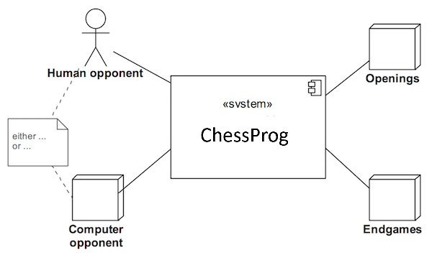

Human opponent (user)
Chess is played between two opponents, who move their pieces in turn. ChessProg takes the role of one of the opponents, and competes against a human opponent. For this purpose, the two need to communicate, e.g. about their moves, or draw offers.

Computer opponent (external system)
As an alternative to a human opponent ChessProg can also compete with a different engine. The requirements related to the exchange of information are the same.

Openings (external system)
About the opening, which is the early stage of a game, extensive knowledge exists in chess literature. This knowledge is partly free and partly also commercially available in the form of libraries and databases. Within ChessProg no such library is created. Optionally an external system is connected instead in order to permit a knowledge based play in the early stages, as expected by human players.

Endgames (external system)
If just a very few pieces are left on the board (e.g. only the two kings and a queen), endgame libraries can be used analogously to opening libraries. For any position with this piece constellation these libraries include the statement whether a position is won, drawn or lost, and if possible the necessary winning move.
Within ChessProg no such library is created. Optionally an external system is connected instead in order to bring clearly won games home safely, or to use the knowledge from the libraries for analysis and position evaluation.

3.2 Deployment Context
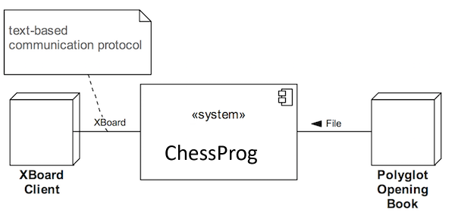

XBoard client (external system)
A human player is connected to ChessProg with a graphical front-end. The development of such is not part of ChessProg. Each graphical frontend can be used instead, if it supports the so-called XBoard protocol. These include Xboard (or Winboard on Windows), Arena and Aquarium.

Polyglot Opening Book (external system)
Polyglot Opening Book is a binary file format for opening libraries. ChessProg allows the optional connection of such books. Only read access is used.

On endgames
The implementation of a connection to endgame databases (such as Nalimov Endgame tablebases) has been dropped due to the effort of implementation). The design, however, is open to appropriate extensions.

4. Solution Strategy

4.1 Introduction to the Strategy
The following table contrasts the quality goals of ChessProg with matching architecture approaches and thus provides easy access to the solution.
Quality Goal | Matching approaches in the solution
Accessible example (Analysability) | - architectural overview structured by arc42  - explicit, object-oriented domain model  - detailed documentation of public interfaces with Javadoc
Platform appealing to experiments (Changeability) | - widely spread programming language Java → (a)  - Interfaces for core abstractions (for instance: position evaluation, game rules)  - immutable objects (position, move, … ) make implementation of many algorithms easier  - “plugging” of elements with dependency injection leads to interchangeability → (b)  - High test coverage as a safety net
Using existing frontends (Interoperability) | - Use of the common communication protocol XBoard, → (c)  - Use of portable Java → (a)
Acceptable playing strength (Attractiveness) | - Integration of chess opening book libraries → (d)  - implementation of minimax algorithm and a proper position evaluation → (e)  - Integration tests with chess problems for tactics and mate positions
Quick response to opponent’s moves (Efficiency) | - Reactive extensions for concurrent calculation with newly found better moves as events → (f)  - Optimization of minimax by alpha-beta pruning → (e)  - Efficient domain model implementation  - Integration tests with time limits
Small letters in brackets, e.g. → (x), link individual approaches from the right hand of the table to the following architectural overview diagram. The remaining section 4 introduces significant architectural aspects and refers to further information.
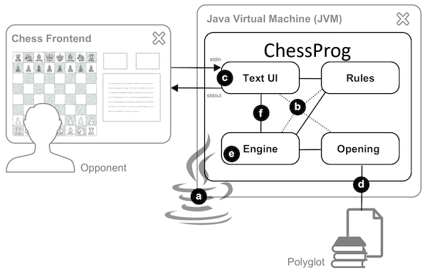

4.2 Structure of ChessProg
ChessProg can be implemented as a Java program with a main routine. It is roughly split into the following parts:
- An implementation of the rules of chess
- The engine itself, which selects the moves
- The connection to a graphical user interface via the XBoard protocol
- An adapter for a specific opening book format (Polyglot Opening Book)
This decomposition allows to replace things such as the communication protocol or the opening book format if necessary. All parts are abstracted through interfaces. Their implementations are assembled via dependency injection. The decomposition further allows the software, especially the chess algorithms, to be tested automatically.
The interaction between algorithms takes place using the exchange of data structures motivated by the domain implemented as Java classes (piece, move and so on). Here, better understandability is preferred at the cost of efficiency. Nevertheless, ChessProg reached an acceptable playing strength, as a run through the corresponding scenarios.
The key element of the data structure design is the game situation. This includes the placement of the chess pieces and other aspects that belong to the position (such as which side moves next). Again readability is preferred to efficiency in the implementation of the class motivated by the domain.

4.4 The Connection of the Engine
ChessProg has no graphical user interface. Instead communication takes place via standard input and output. The text-based XBoard acts as a communication protocol ( “How does the engine communicate with the outside world?"). You can use ChessProg interactively with the command line if you know the XBoard commands and are able to interpret the engine responses.
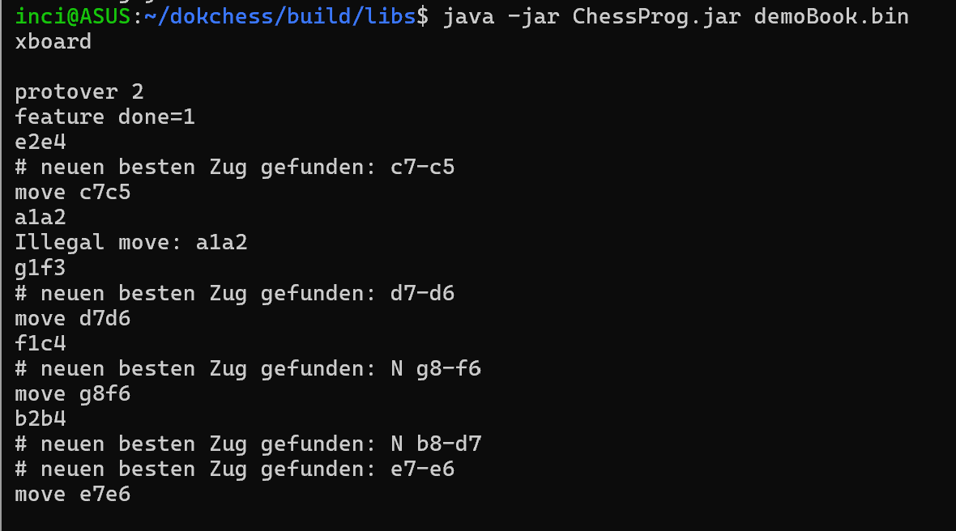
The actual ChessProg engine is attached by a reactive approach (“Reactive Extensions”). ChessProg is accessible even during its analysis. This way, for instance a user can force the engine to move immediately.
On Windows, integrating ChessProg in a UI is done with a batch file (*.bat). It starts the Java Virtual Machine (JVM) with the class with the main method as a parameter.

5 Building Block View

5.1 Building Block View, Level 1

ChessProg breaks down in four subsystems as presented below. The dashed arrows represent logical dependencies between the subsystems (“x -> y” for “x depends on y”). The squared boxes on the membrane of the system are interaction points (“ports”) with the outside world.
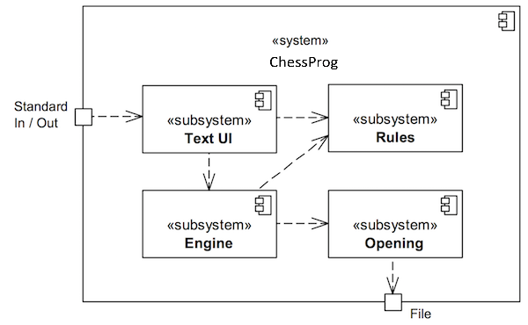
Subsystem | Short description
Text UI | Realizes communication with a client using the XBoard protocol.
Rules | Provides the rules of chess and for instance can determine all valid moves for a position.
Engine | Contains the determination of a next move starting from a game situation.
Opening | Provides standard moves of the chess opening literature for a game situation.

5.2 Subsystem Text UI

Intent/Responsibility
This subsystem implements the communication with a client (for example, a graphical user interface) using the text-based XBoard. It reads commands from standard input, checks them against the rules of the game and converts them for the Engine. Responses from the Engine (especially the moves) will be accepted by the subsystem as events, formatted according to the protocol and returned via standard output. Thus the subsystem is driving the whole game.

Interfaces
The subsystem provides its functionality via the Java class org.ChessProg.textui.xboard.XBoard.
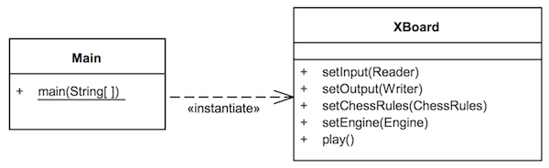
Method | Short description
setInput | Set the protocol input with a dependency injection (→ Concept V.8.1). Typically, the standard input (stdin), automated tests use a different source.
setOutput | Set the protocol output. Typically, the standard output (stdout), automated tests may use a different target.
setChessRules | Sets an implementation of the game rules
setEngine | Sets an implementation of the engine
play | Starts the actual communication (input / processing / output) in a infinite loop until the quit command.

5.3 Subsystem Rules

Intent/Responsibility
This subsystem accounts for the rules of chess according to the International Chess Federation (FIDE). It determines all valid moves for a position and decides whether it is a check, a checkmate or a stalemate.

Interfaces
The subsystem provides its functionality via the Java interface
org.ChessProg.rules.ChessRules.
Default implementation of the interface is class
org.ChessPorg.rules.DefaultChessRules.
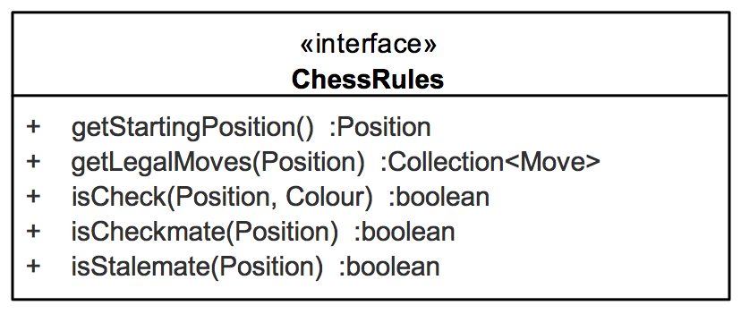
Method | Short description
getStartingPosition | Returns the starting position of the game. White begins.
getLegalMoves | Returns the set of all legal moves for a given position. The current player is determined from the position parameter. In case of a mate or stalemate an empty collection is the result. Thus the method never returns null.
isCheck | Checks whether the king of the given colour is attacked by the opponent.
isCheckmate | Checks whether the given position is a mate. I.e. the king of the current player is under attack, and no legal move changes this. The player to move has lost the game.
isStalemate | Checks whether the given position is a stalemate. I.e. the current player has no valid move, but the king is not under attack. The game is considered a draw.

5.4 Engine (Blackbox)

Intent/Responsibility
This subsystem contains the determination of a next move starting from a game position. The position is given from outside. The engine itself is stateful and always plays one game at the same time. The default implementation needs an implementation of the game rules to work. An opening library, however, is optional.

Interfaces
The Engine subsystem provides its functionality via the Java interface
org.ChessProg.engine.Engine.
Default implementation is the class
org.ChessProg.engine.DefaultEngine.
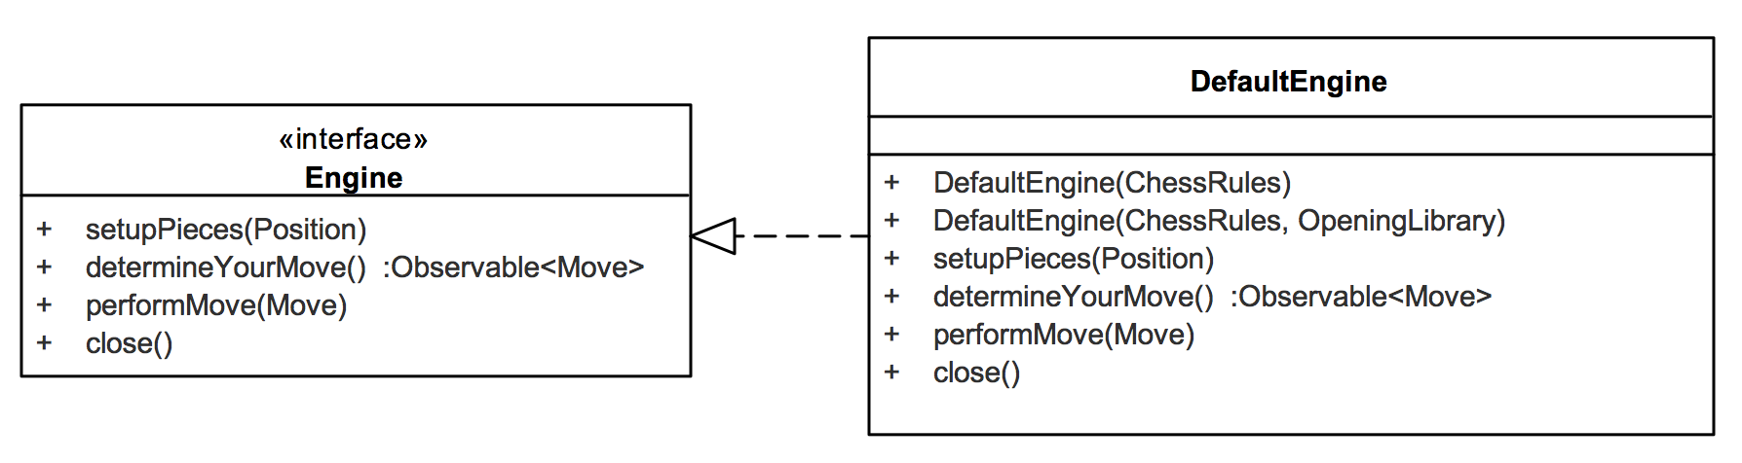
Method | Short description
setupPieces | Sets the state of the engine to the specified position. If currently a move calculation is running, this will be cancelled.
determineYourMove | Starts the determination of a move for the current game situation. Returns move candidates asynchronously via an Observable ( “Move Determination Walkthrough”). The engine does not perform the moves.
performMove | Performs the move given, which changes the state of the engine. If currently a move calculation is running, this will be canceled.
close | Closes the engine. The method makes it possible to free resources. No move calculations are allowed afterwards.

5.5 Subsystem Opening (Blackbox)

Intent/Responsibility
This subsystem provides opening libraries and implements the Polyglot opening book format. This format is currently the only one available, which is not proprietary. Corresponding book files and associated tools are freely available on the Internet.

Interfaces
The Opening subsystem provides its functionality via the Java interface
org.ChessProg.opening.OpeningLibrary.
The class org.ChessProg.opening.polyglot.PolyglotOpeningBook provides one possible implementation.

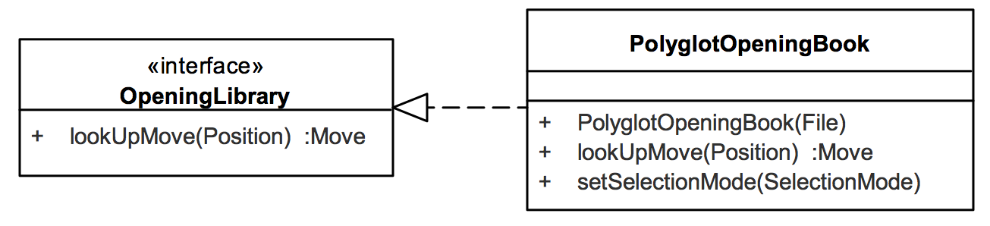
Method | Short description
lookUpMove | Returns a standard move for the specified position from the library, or null.

PolyglotOpeningBook
The PolyglotOpeningBook class is an adapter for the Polyglot opening book file format. Implementation of OpeningLibrary that reads a binary file in the appropriate format and returns a move to the specified position, if the library contains any.
Method | Short description
PolyglotOpeningBook | Constructor, expects the input file.
setSelectionMode | Sets the mode to select a move, if there is more than one candidate in the library for the given position.

5.6 Level 2: Engine (Whitebox)
The engine breaks down in modules Search and (position) Evaluation as shown in the following diagram. If available, the determination of the move is initially delegated to an opening book. Only if the book does not provide a standard move Search is used.
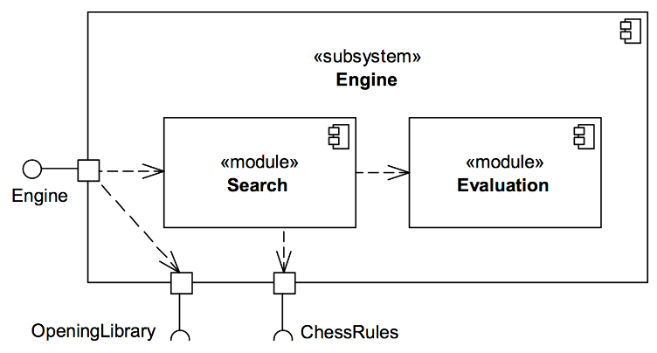
Module | Short description
Search | Determines the optimal move for a position under certain conditions.
Evaluation | Evaluates a position from an opponent’s perspective.

5.7 Search (Blackbox)

Intent/Responsibility
The module determines the optimal move for a position under certain conditions. In the game of chess an optimal move always exists, theoretically. The high number of possible moves and the resulting incredible mass of game situations to consider makes it impossible to determine it in practice. Common algorithms like the Minimax therefore explore the “game tree” only up to a certain depth.

Interfaces
The module provides its functionality via the Java interface
org.ChessProg.engine.search.Search.
Class org.ChessPorg.engine.search.MinimaxAlgorithm implements the interface with the Minimax algorithm. The class MinimaxParallelSearch uses the algorithm and implements the same interface Search. It examines several subtrees concurrently; if it finds a better move the caller receives a message onNext via the observer pattern. The search indicates the completion of its work with the message onComplete.
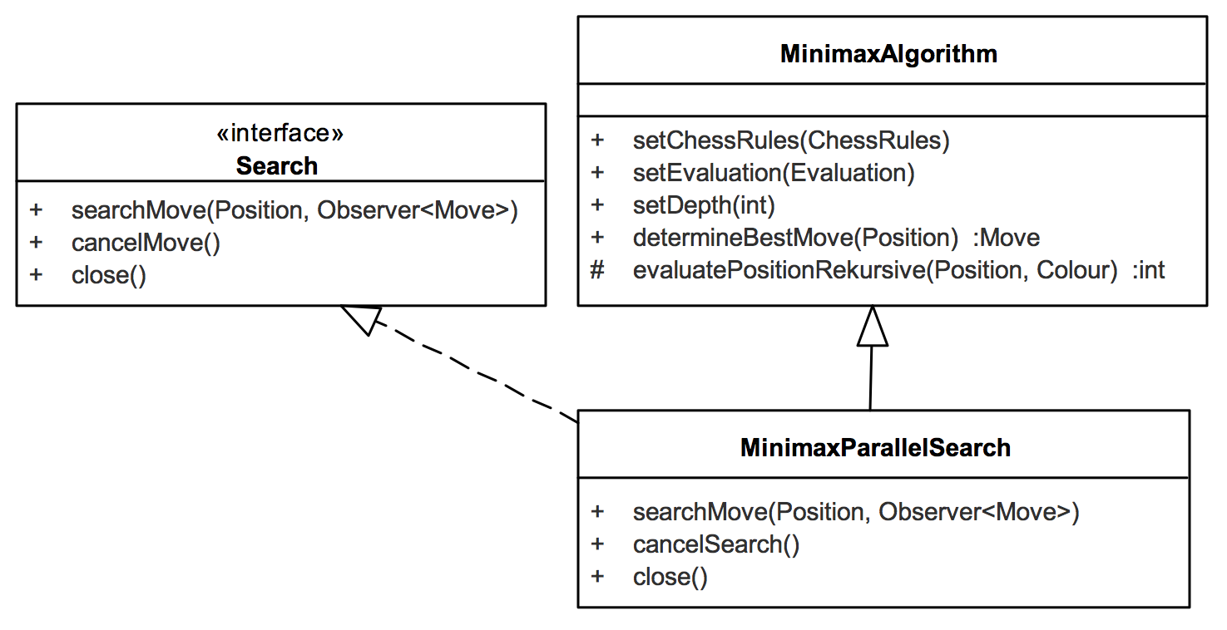
Method | Short description
searchMove | Starts a search for a move on the specified position. Returns gradually better moves as events on the passed observer. The end of the search (no better move found) is also signaled to the observer.
cancelSearch | Cancels the current search.
close | Closes the search completely. No moves may be determined after calling this method.
Method | Short description
setEvaluation | Set the evaluation function on which the positions are rated when the maximum search depth is reached
setChessRules | Sets an implementation of the chess rules via dependency injection
setDepth | Set the maximum search depth in half moves. That means at 4 each player moves twice.
determineBestMove | Determines the optimal move according to minimax for the position passed and given evaluation at fixed search depth. The method blocks and is deterministic.

5.8 Evaluation (Blackbox)

Intent/Responsibility
The module evaluates a position from an opponent’s perspective. Result is a number where 0 is a balanced situation. A positive number describes an advantage for the player, a negative one a drawback. The higher the number, the greater the advantage or disadvantage. The module makes it therefore possible to compare positions with each other.

Interfaces
The Evaluation module provides its functionality via the Java interface
org.ChessProg.engine.eval.Evaluation.
The class org.ChessProg.engine.eval.StandardMaterialEvaluation is a very simple implementation. The interface contains constants for typical ratings.
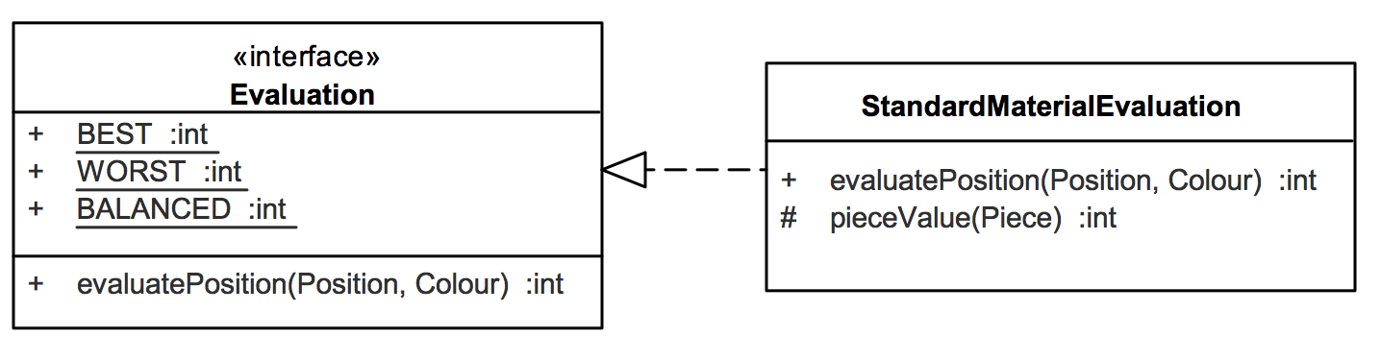
Method | Short description
evaluatePosition | Returns an evaluation value for the given position from the view of the specified player’s colour. The higher the better.

StandardMaterialEvaluation
The implementation class StandardMaterialEvaluation takes only the present pieces (material) into account. Each piece type has a value (pawn 1, knight 3, …, queen 9). The pieces on the board are added accordingly. Own figures are positive, opponent’s pieces negative. Accordingly, with balanced material the result is 0. If you lose a queen, the value drops by 9.

6. Runtime View

6.1 Move Determination Walkthrough

After establishing the XBoard protocol, the client (white) starts a game by indicating a move. The following sequence diagram shows an example interaction at the subsystem level from the input “e2e4” (white pawn e2-e4) to ChessProg' response, which is the output “move b8c6” (black knight b8-c6, “Nimzowitsch defense”).

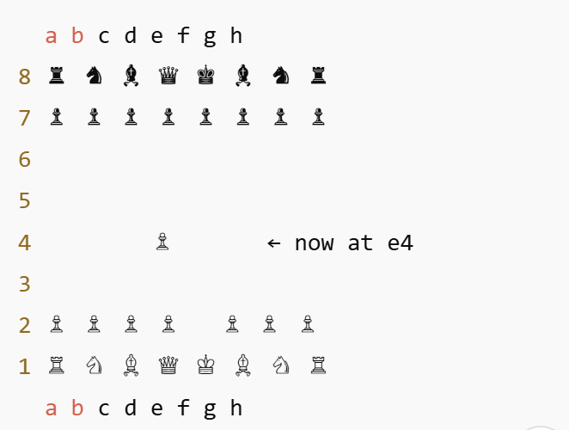
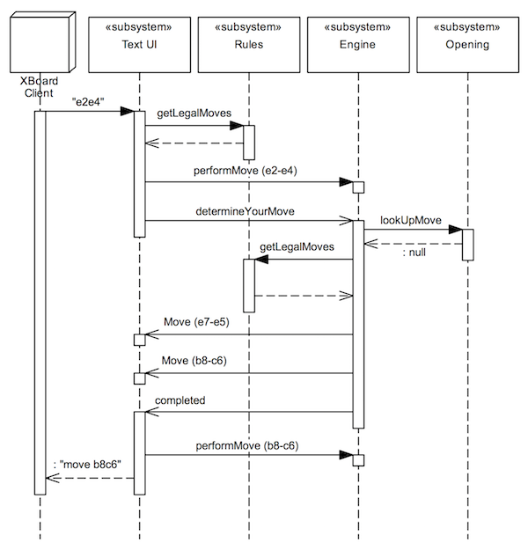
First, the Text UI subsystem validates the input with the aid of the Rules subsystem ( “Plausibility Checks and Validation”). The move in the example is recognized as legal and performed on the (stateful) Engine (the performMove message) afterward. Then, the Text UI subsystem asks the engine to determine its move. Since move computation can take a long time, but ChessProg should still continue to react to inputs, this call is asynchronous. The engine comes back with possible moves.
The Engine examines at first whether the opening book has something to offer. In the example, this is not the case. The engine has to calculate the move on its own. It then accesses the Rules and determines all valid moves as candidates. Afterward, it investigates and rates them, and gradually reports better moves (better from the perspective of the engine) back to the caller (the Text UI subsystem). Here, the observer pattern is used (implementation with reactive extensions).
The example diagram shows that two moves have been found (pawn e7-e5, knight b8-c6) and finally the message, that the search is complete, so the engine does not provide better moves. The Text UI subsystem takes the last move of the Engine and prints it as a string to standard output according to the XBoard protocol: “move b8c6”.

7. Deployment View

7.1 Windows Infrastructure

The following deployment diagram shows the use of ChessProg on Windows without an opening book. Arena is used as an example frontend ( “How does the engine communicate with the outside world?").
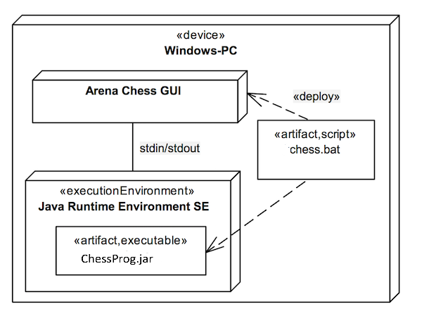
Software Requirements on a PC:
- Java Runtime Environment
- The JVM (javaw.exe) is in the PATH, otherwise adapt chess.bat
- Arena
ChessProg.jar contains the compiled Java source code of all the modules and all the necessary dependencies (“Uber-jar”). The script file chess.bat starts the Java Virtual Machine with ChessProg. Both are available on the computer in a common directory, because chess.bat relatively addresses the jar file.
Within Arena, the script file is declared in the following menu “Engine | Install a new Engine …”. You will see a file selection, the file type can be limited to _* .bat_ files. Then, set the engine type to “Winboard”. In other chess frontends, declaring an engine is very similar See corresponding documentation for details.

8 Technical and Crosscutting Concepts

8.1 Dependencies Between Modules
ChessProg is designed for flexibility and extensibility. In order to do so, the modules are loosely coupled. ChessProg modules are implementations of Java interfaces. Java classes that require parts signal this with appropriate methods set«Module»(«Interface» …). They don’t take care of resolving a dependency, for instance, by using a factory. Instead, the client resolves the dependencies by creating suitable implementations with new and putting them together with setter methods (also known as Dependency Injection, short DI).
Interfaces and DI enable alternative implementations within ChessProg. Adding functionality with the help of the decorator pattern (Gamma+94) is possible as well. Furthermore, aspect-oriented programming (AOP) solutions, which rely on Java dynamic proxies, are applicable interfaces. Plus, this handling of dependencies positively affects testability.
ChessProg abstains from the use of a concrete DI framework. The modules are hard-wired in the code, however only in unit tests and glue code (for example, the main class). No annotation driven configuration is present in the code. In Java, annotation-driven configuration refers to using Java annotations (special @Something markers) to control how things like dependency injection (DI), object creation, and wiring are handled — usually by a framework like Spring.

8.2 Chess Domain Model
The different modules of ChessProg exchange chess-specific data. This includes the game situation on the chessboard (position) for instance, as well as opponent’s and own moves. All interfaces use the same domain objects as call and return parameters.
This section contains a brief overview of these data structures and their relationships. All the classes and enumeration types (enums) are located in the org.ChessProg.domain package. See the source documentation (javadoc) for details.
A chess piece is characterized by colour (black or white) and type (king, queen, and so on). In the ChessProg domain model, a piece does not know its location on the board. The Piece class is immutable, and so are all other domain classes.
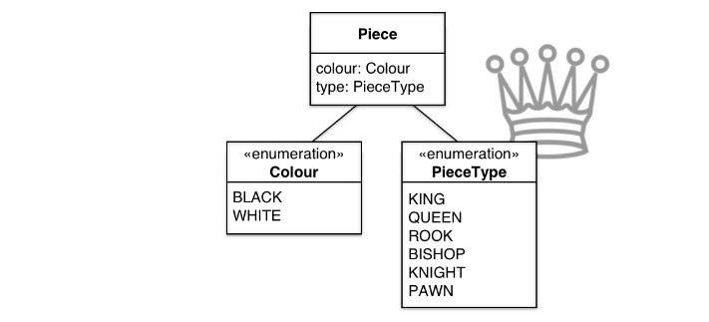
A chessboard consists of 8 x 8 squares, which are arranged in 8 rows called ranks (1-8) and 8 columns called files (a-h). The Square class describes one of these. Since a square can be occupied by only one piece, source and target squares are sufficient to specify a move (the Move class). The only exception is the promotion of a pawn on the opponent’s baseline. Here, the player decides which piece type they want to convert the pawn to (typically, but not necessarily, a queen). Castling moves are represented as king moves over two squares in the corresponding direction. The additional attributes for the moving piece and whether the move is a capture are useful for the analysis tasks of the engine.
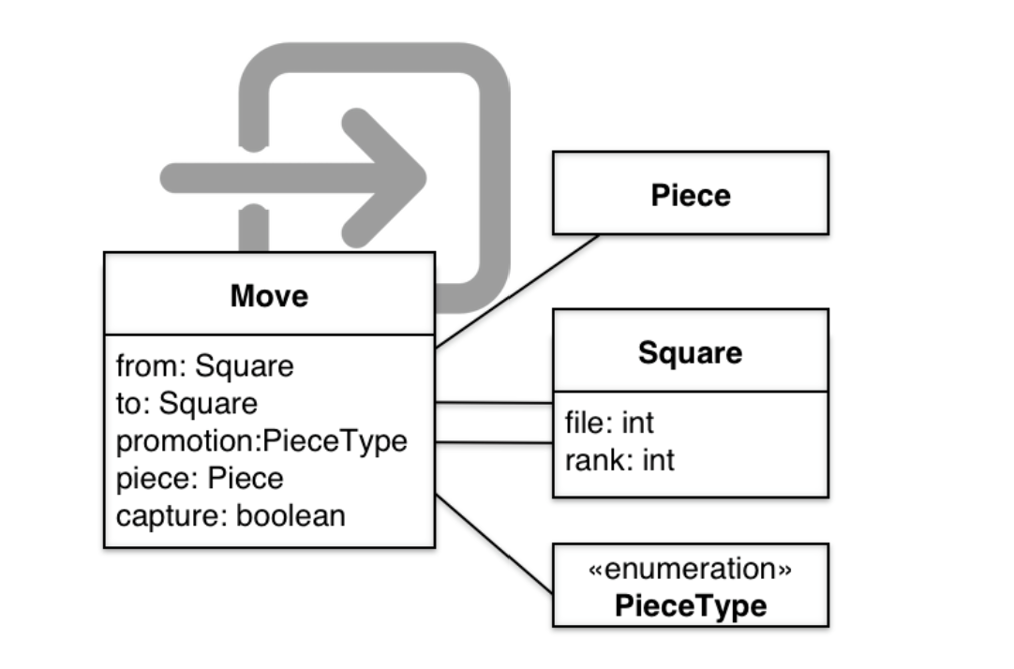
The Position class describes the current situation on the board. In particular, these are the piece locations on the board, which are internally represented as a two-dimensional array (8 x 8). If a square is not occupied, null is stored in the array. To complete the game situation, the Position class includes information about which side moves next, which castlings are still possible (if any), and whether capturing en passant is allowed.
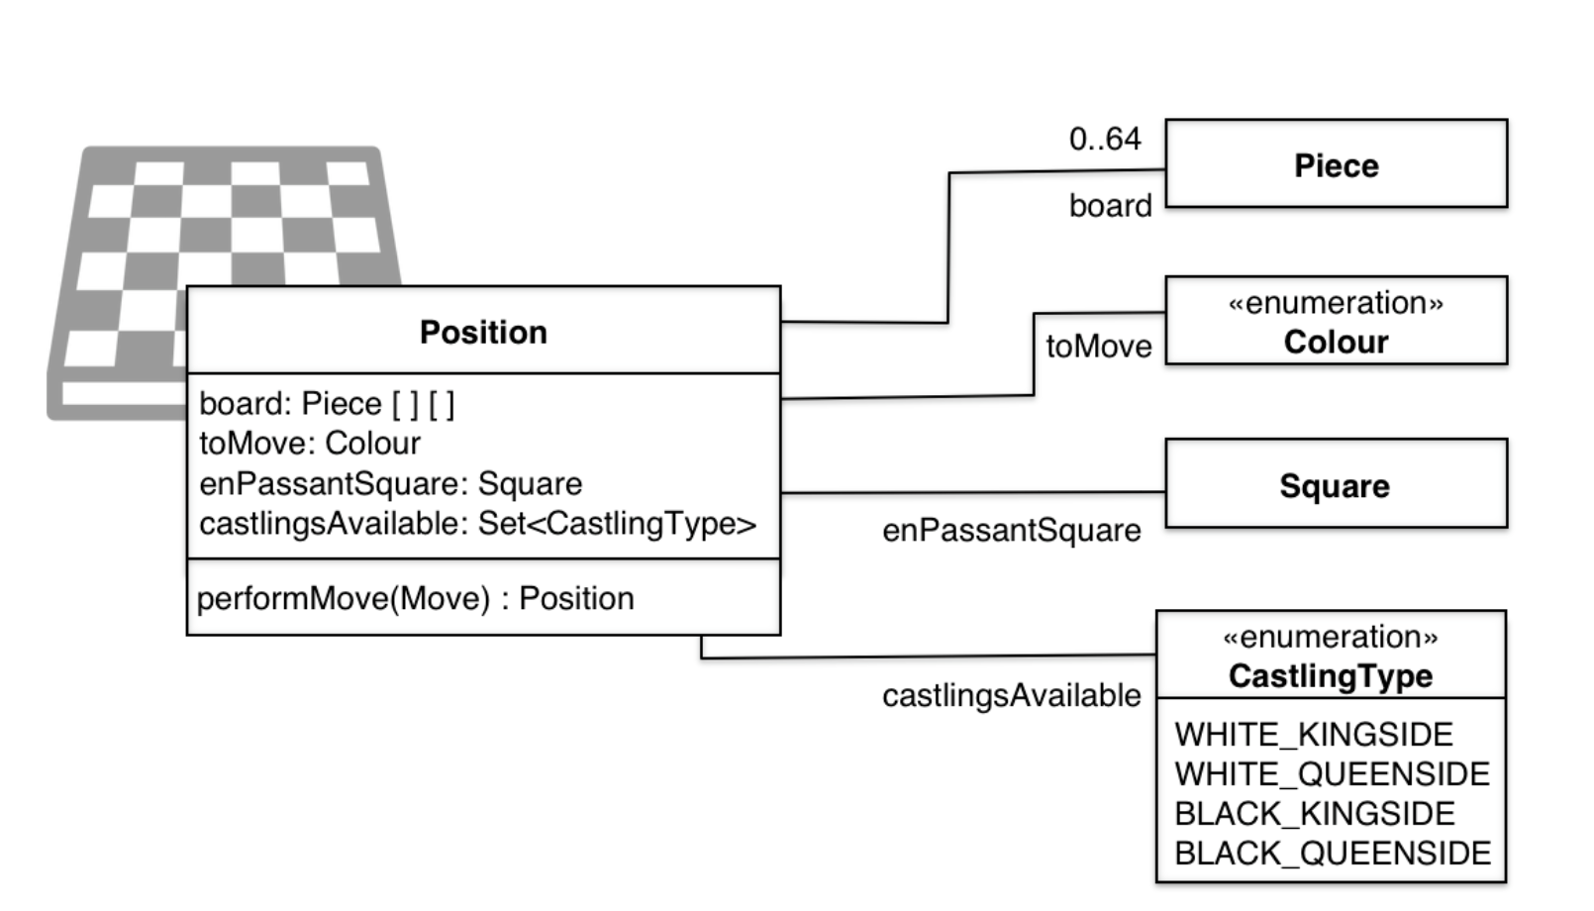
The Position class is immutable as well. Therefore, the performMove() method returns a new position with the modified game situation.

8.3 User Interface

ChessProg itself has no graphical user interface. It interacts via the XBoard protocol with the outside world.
The XBoard protocol is text-based. The table below shows a sample dialog, all commands are terminated with a new line). By default the engine plays black. You can change this with the “white” command of XBoard.
Client → ChessProg | ChessProg → Client | Comments
xboard |  | client wants to use the XBoard-Protocol (required since engines partly understand other, sometimes even multiple protocols)
 | (new line)
protover 2 |  | protocol version 2
 | feature done=1 | line by line notification of additional features of the engine (here: none)
e2e4 |  | white plays pawn e2-e42
 | move b8c6 | black (DokChess) plays knight b8-c6
quit |  | client ends the game (DokChess terminates)
Mann+2009 describes the protocol itself in detail. In ChessProg the Text UI subsystem is responsible for the protocol implementation.
A more typical use of ChessProg is a graphical chess frontend like Arena (see image below). It accepts the moves of the opponent in a comfortable interface, passes them to ChessProg in the form of XBoard commands like in the table above (column “Client → ChessProg”) and translates the answers (column “ChessProg → Client”) graphically.
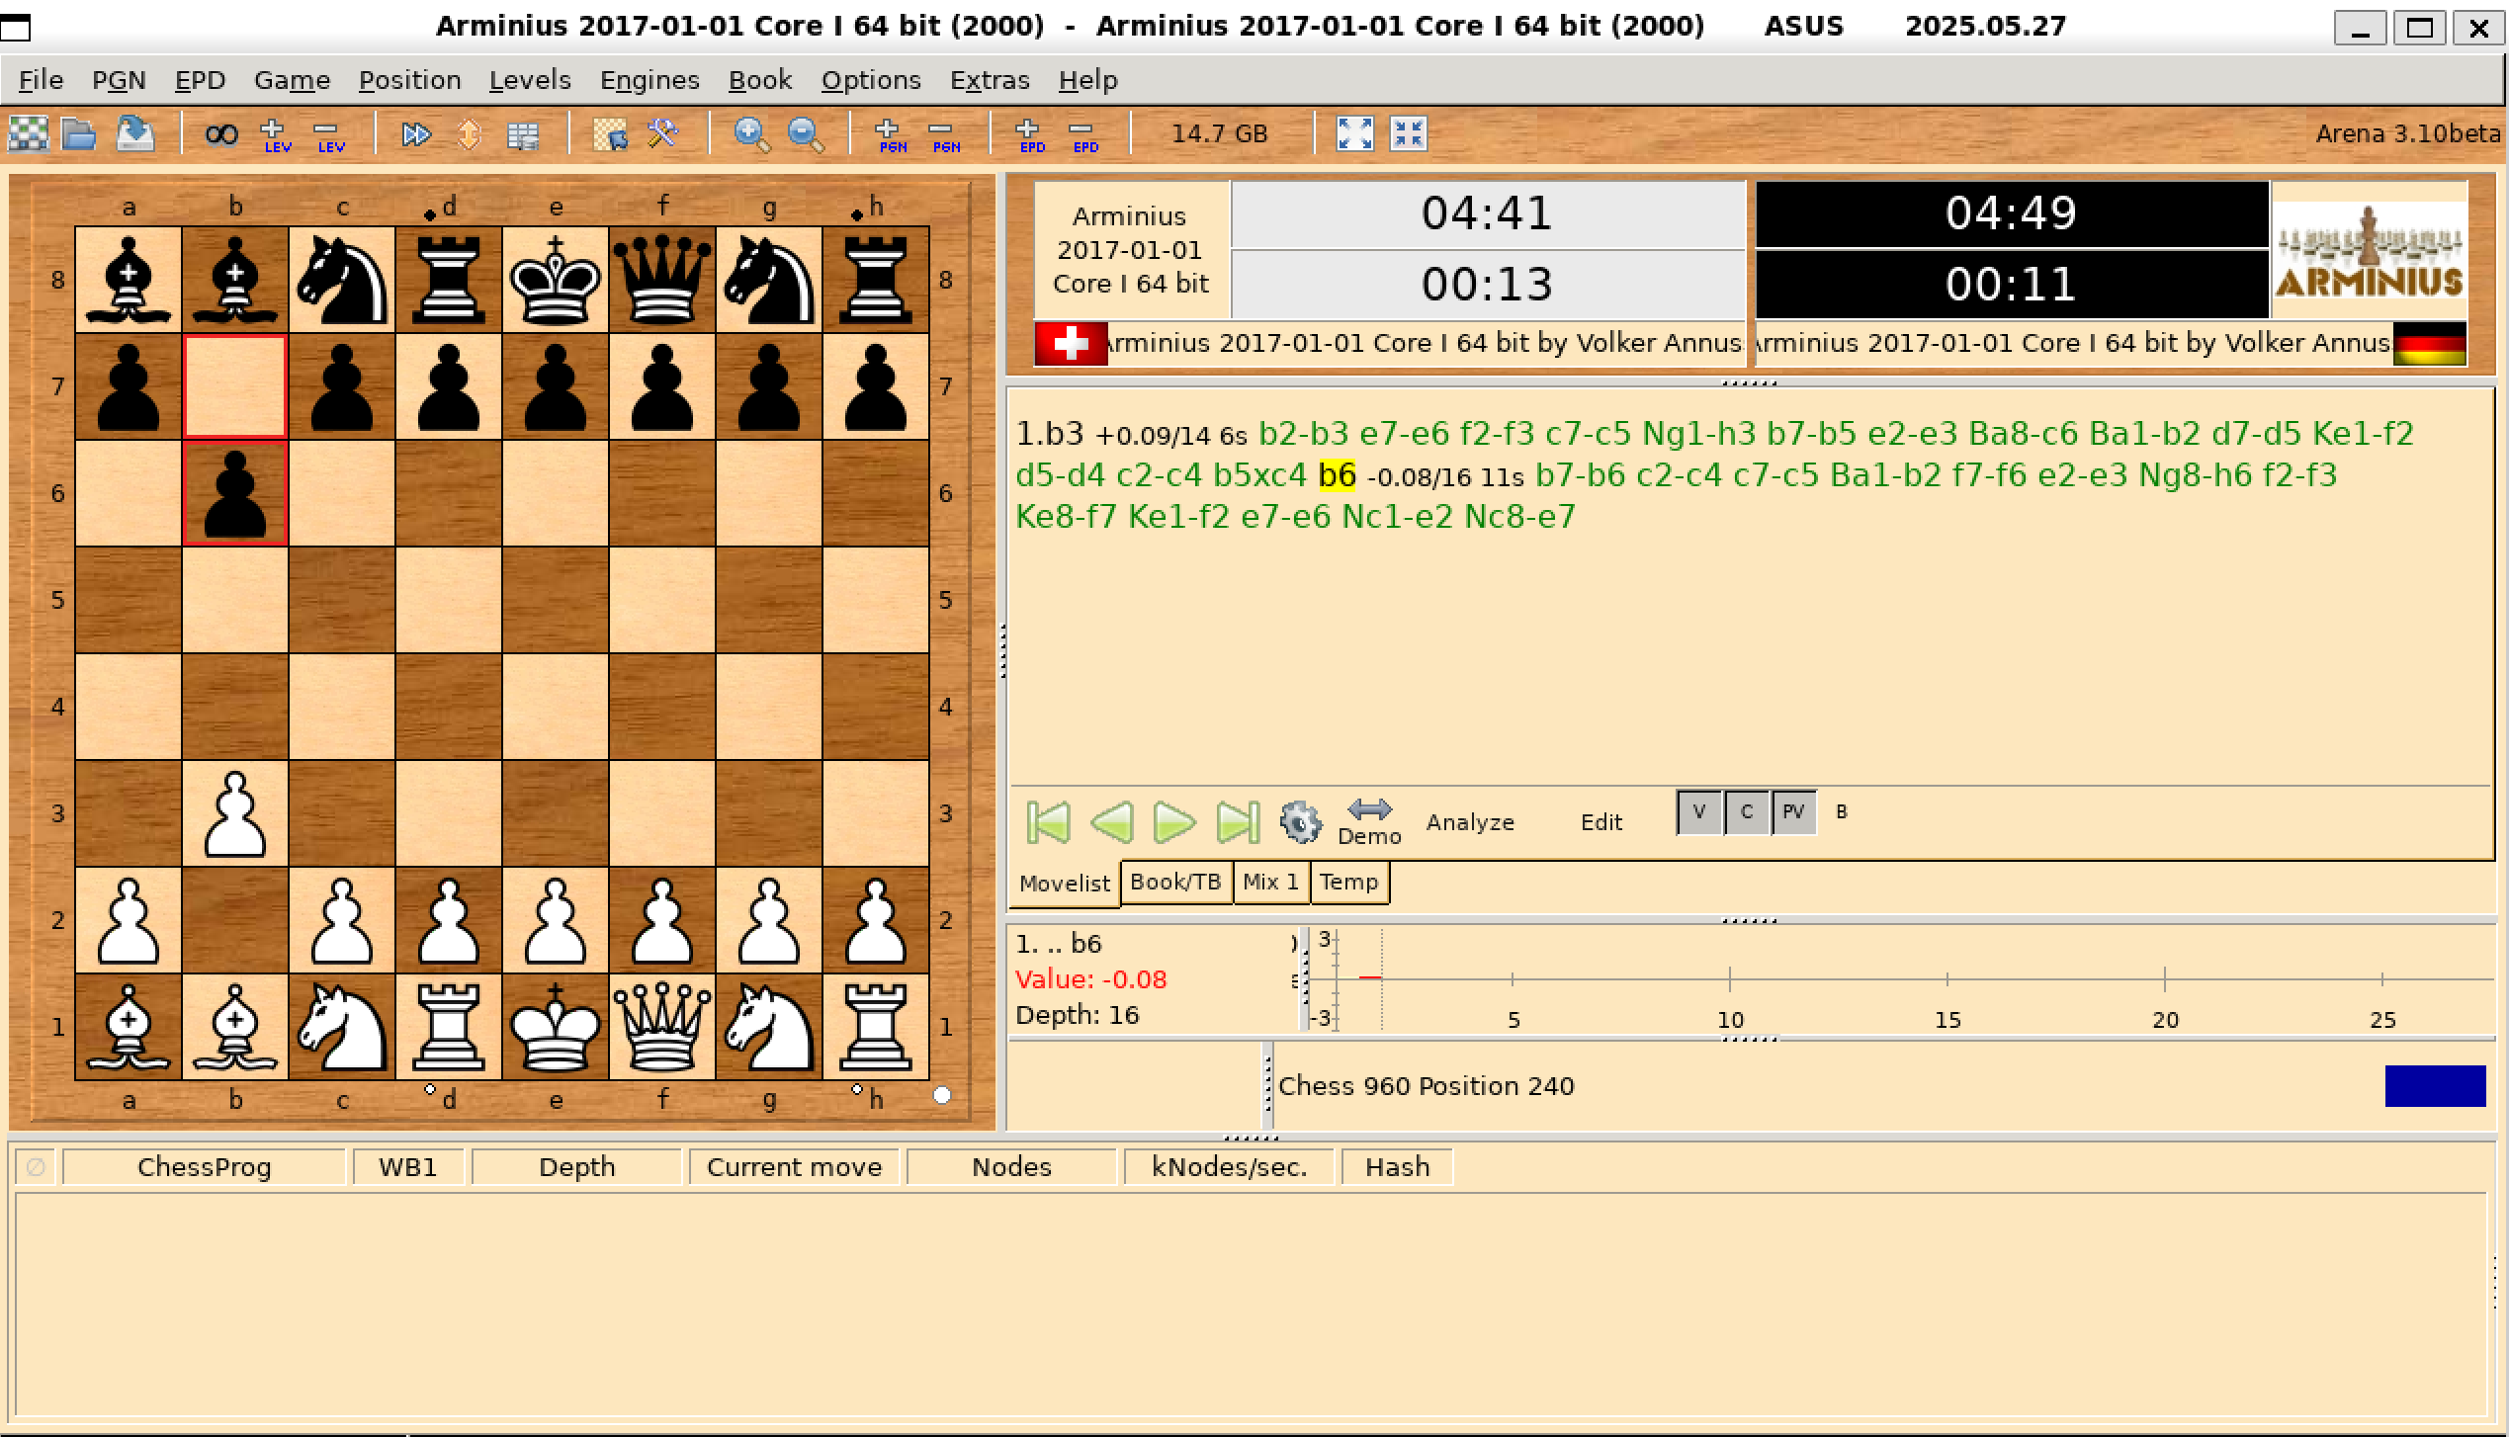

8.4 Plausibility Checks and Validation

In simple terms, ChessProg is an algorithm. It responds to moves of the opponent with its own moves. Two channels are relevant for input validation:
- the XBoard protocol for interactive user input from the opponent
- opening libraries in the form of files
Input that comes through the XBoard protocol is parsed from the corresponding subsystem. In case of unknown or unimplemented commands ChessProg reports the XBoard command “Error” back to the client.
In case of move commands ChessProg checks using the rules subsystem whether the move is allowed or not. In case of illegal moves ChessProg reports the XBoard command “Illegal move” back to the client. When using a graphical front end, this case should not occur, since these typically accept only valid moves. The case is likely relevant when interacting via command line.
Inputs that come through the XBoard protocol are parsed from the corresponding subsystem. For unknown or unimplemented commands ChessProg reports the XBoard command “Error” back to the client. When setting up a position ChessProg checks the compliance with the protocol, but not whether the position is permitted. In extreme cases (e.g. if no kings are present on the board), the engine subsystem may raise an error during the game.
For opening libraries ChessProg only checks whether it can open and read the file. In case of a failure (e.g. file not found) it raises an exception “Exception and Error Handling”). While reading the file the opening subsystem responds with a runtime error to recognized problems (for example, invalid file format). However, the content of the library itself is not checked. For example, if invalid moves are stored for a position it is not recognized. The user is responsible for the quality of the library. In extreme cases, the engine may respond with an illegal move.
8.5 Exception and Error Handling
ChessProg has no own user interface. Therefore it must indicate problems to the outside world.
All ChessProg subsystem methods throw Runtime Exceptions. In addition in case of the Engine subsystem error messages (onError) may occur during an asynchronous search. Own extensions (for example a custom search) must be implemented accordingly. Checked exceptions (e.g. java.io.IOException) need to be wrapped in Runtime Exceptions.
The javadoc of methods and constructors in question shows the rare cases where exceptions are expected in ChessProg. Trouble reading an opening book file, or when trying move calculation within the engine at an invalid position (if identified). All other exceptions would be programming errors.
The Text UI subsystem catches all exceptions and communicates them via the XBoard protocol outwards (command “tellusererror”). A graphical front-end usually visualizes them in an error dialog or alert box. The image below depicts that for the chess frontend Arena.
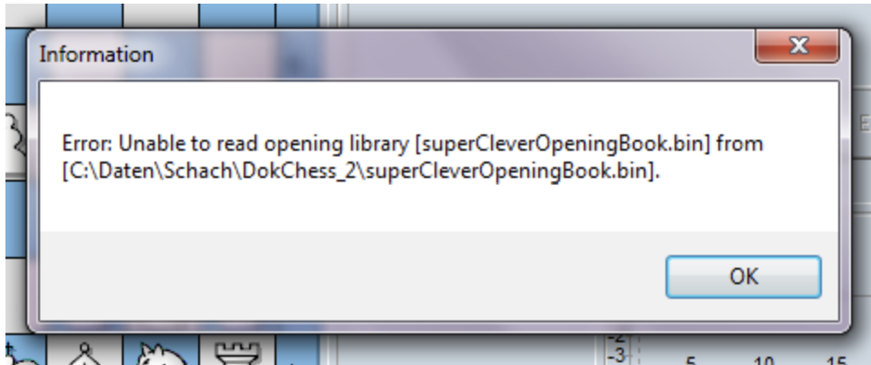

8.6 Logging and Tracing

For improvements and extensions the analysis capabilities provided by ChessProg are of note, particularly in case of on error.
The ChessProg functionality itself can be checked easily with unit tests. This is particularly true for the correct implementation of the game rules and for the game play of the engine. It holds true for your own extensions in this area as well.
Therefore there is no fine-grained logging output within ChessProg. Solutions like SLF4J are not present. In this way we avoid a dependency to an external library and the source code is not polluted by this aspect at all.
For the communication between the client and ChessProg via the XBoard protocol – in addition to interactive operation via a shell – the client may monitor the conversation. Common chess frontends permit this by writing log files and/or a simultaneous display of a log window during the game. The image below shows this functionality within Arena
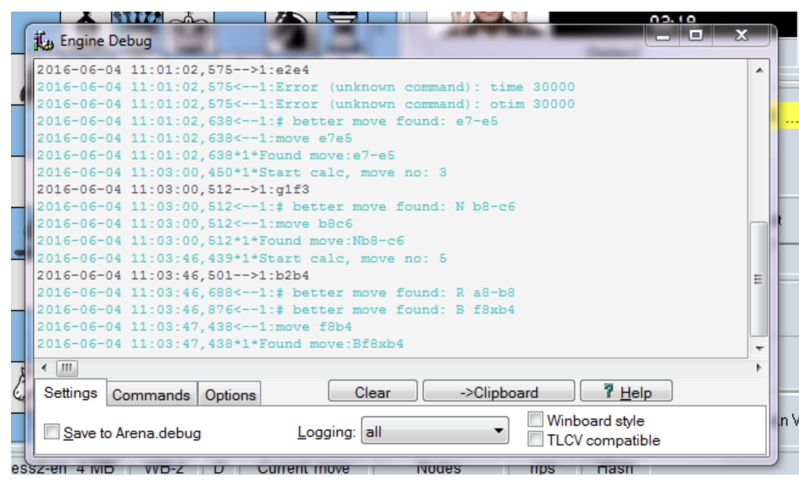

8.7 Testability

The functionality of the individual modules of DokChess is ensured by extensive unit tests in folder src/test next to src/main, where the Java source code of the modules is stored. It mirrors the package structure, and in the corresponding packages unit tests for the classes realized with JUnit 4.

9. Design Decisions

9.1 How Does the Engine Communicate with the Outside World?

Problem Background
As a central requirement ChessProg must work together with existing chess frontends. How do we connect them?
A whole series of graphical user interfaces are available for playing against chess programs. Moreover, there are software solutions with a larger scope for chess enthusiasts. In addition to the game “Human vs. Machine”, they offer more functionality, such as analyzing games. Over time, new chess programs will be released – and others will possibly disappear from the market.
Depending on how the connection with such programs is realized, ChessProg can or can not communicate with specific frontend clients. Thus, the issue affects ChessProg interoperability with existing chess software and its adaptability to future chess software.

Influences on the Decision
- Constraints
- Operation of the frontend at least on Windows desktop operating systems
- Support for freely available frontends
- Favoring established (chess) standards
- Significantly Affected Quality Attributes
- Quality Goal: Using existing frontends (Interoperability)
- Quality Goal: Platform appealing to experiments (Changeability)
- Adaptability (to future chess software)
- Affected Risks
- Connecting to the Frontend fails

Assumptions
- The investigation of just a few available frontends leads to all interesting integration options.

Considered Alternatives
The following chess frontends were investigated:
- Arena Chess GUI (available for free, runs on Windows)
- Fritz for Fun (commercially provided by ChessBase GmbH, runs on Windows)
- Winboard / XBoard (Open source, runs on Windows, Mac OS X, *nix)
As a result, two communication protocols have been identified as options:
- Option 1: UCI Protocol (universal chess interface), see hier
- Option 2: XBoard Protocol (also known as Winboard and as Chess Engine Communication Protocol), see hier
Neither of the two protocols are formally specified, but both are publicly documented.
Both protocols are text-based, and communication between the frontend and the engine is via stdin/stdout. In both cases the front end starts the engine in a separate process.
The following Table compares the three investigated frontends to their implemented protocols:
Item | Arena 3 | Fritz for fun | Winboard / XBoard
UCI | Yes | Yes | -
XBoard-Protocol | Yes | - | Yes

Decision
Under the given constraints, the quality goals can generally be achieved with both options. Depending on which protocol is implemented, different front ends are supported.
The decision in favor of the XBoard protocol was. The structure of ChessProg allows us to add alternative communication protocols (UCI or other) without having to change the engine itself for this, see dependencies in the building block view.
The preferred front end for Windows is Arena. It is freely available and tops the functionality of WinBoard. It has good debugging facilities. For example, it can present the communication between the frontend and the engine live in a window. Arena supports both protocols.
By opting for the XBoard protocol, other operating systems (in addition to Windows, especially Mac OS X and Linux) are also supported with freely available frontends (see the preceding table). As such, a larger circle of interested developers may use the engine, which was finally essential.

9.2 Are Position Objects Changeable or Not?

Problem Background
For various ChessProg modules, game situations on the chess board (so-called positions) must be provided and exchanged between them. Do we make the associated data structure changeable or unchangeable (immutable)?
During a game, the position changes when the opposing players move their pieces. In addition, the engine performs possible moves in its analysis, tries to counter the moves of the opponent, evaluates the outcoming positions, and then discards moves. The result is a tree that contains many thousands of different positions, depending on the search depth.
Depending on whether the position is immutable as a data structure or not, algorithms are easier or more difficult to implement, and its execution is efficient in a different way.
All modules depend on the position interface. A subsequent change would affect all of ChessProg.

Influences on the Decision
- Constraints
- Implementation in Java
- Moderate hardware equipment
- Significantly Affected Quality Attributes
- Quality Goal: Platform appealing to experiments (Changeability)
- Quality Goal: Acceptable playing strength (Attractiveness)
- Quality Goal: Quick response to opponent’s moves (Efficience)
- Affected Risks
- Implementation effort too high
- Achieving the playing strength fails

Assumptions
- It is possible to implement a data structure with a fine-grained object model (that is, classes such as Piece and Move) that is efficient enough to provide the required playing strength within an adequate response time.
- In the future, concurrent algorithms should be implemented with the data structure as well.

Considered Alternatives
The starting point is domain-driven classes for square, piece and move. These classes are realized immutable as value objects (the e4 field always remains e4 after it’s construction).
For the position, two alternatives are considered:
- Option (1): The position is changeable. Individual methods of the interface, for example, performing moves or taking them back, change the object state.
// Pseudocode
Position p = new Position(); // starting position, white side to move
p.performMove(e2e4); // king's pawn advances two squares, black to move
p.takeBackLastMove() // starting position again
...
- Option (2): The position is unchangeable (“immutable”). That means a method for performing a move provides the new position (it copies the old one, then the move happens) as another immutable object as the result.
Position p = new Position();
newPosition = p.performMove(e2e4); // p keeps unchanged
...
The following table summarizes the strengths and weaknesses of the two options, they are explained below.
 | (1) changeable | (2) unchangeable
Implementation effort | (-) higher | (+) lower
Efficiency (memory consumption) | (+) more economical | (-) higher demand
Efficiency (time behaviour) | (o) neutral | (-) worse
Suitability for concurrent algorithms | (-) bad | (+) good

Option (1): The Position is Changeable
(+) Positive Arguments
The position with its extensive state is not copied in each move. This saves memory and CPU time, and it treats the garbage collector with care. For analysis algorithms, however, it is necessary to implement functionality that takes back the effect of moves (“undo”). This Undo also takes time, hence the neutral rating (o) for the time behavior.
(-) Negative Arguments
The implementation of an Undo-functionality is complex. Not only does it have to set up captured pieces back on the board, the castling rule and en passant require special treatment as well. The Gamma+94 Command pattern suggests itself as an option. The use of that pattern within algorithms is also more complex because the latter must explicitly call methods to take back the moves.
Finally, changeable state has drawbacks related to concurrency.

Option (2): The Position is Unchangeable
(+) Positive Arguments
When you perform a move, the position is copied. It does not change the original. This eliminates the implementation of move reversal (Undo). Clients can simply store the old position as a value. This saves effort in the implementation compared to option (1).
Immutable objects offer significant advantages in concurrent algorithms.
(-) Negative Arguments
Copying the state for each new position takes time. When analyzing situations, it covers many positions, which can take a lot of time.
Beyond that, copying the state for each new position costs memory. The implementation of search algorithms with backtracking at least prevents complete game trees from ending up on the heap. Nevertheless, more memory is required, and the garbage collector has more work to do.
Both points have a negative effect on efficiency.

Decision
The decision for the unchangeable position (option 2) was made due to the advantages in terms of ease of implementation and the prospect of exploiting concurrency. All the disadvantages of option 2 are related to efficiency.
Due to the risk of failing to achieve the objectives with respect to the playing strength in an acceptable computing time (attractiveness, efficiency), prototypes of both versions have been implemented and compared in a mate search (Checkmate in three moves) with the minimax algorithm. With option 2, the search took 30% longer, assuming you implement copying efficiently. But this option met the constraints still well.
Further optimization options could reduce the efficiency disadvantage compared with option 1, if necessary. But they have not been implemented in the first run in order to keep the implementation simple. These options included the use of multiple processors/cores with concurrent algorithms. In the meantime, this was illustrated with a parallel minimax example.

10 Quality Requirements

10.1 Utility Tree
The following diagram gives an overview of the relevant quality attributes and their associated scenarios. The quality goals are also included in the figure, and each refers to the scenarios that illustrate them.
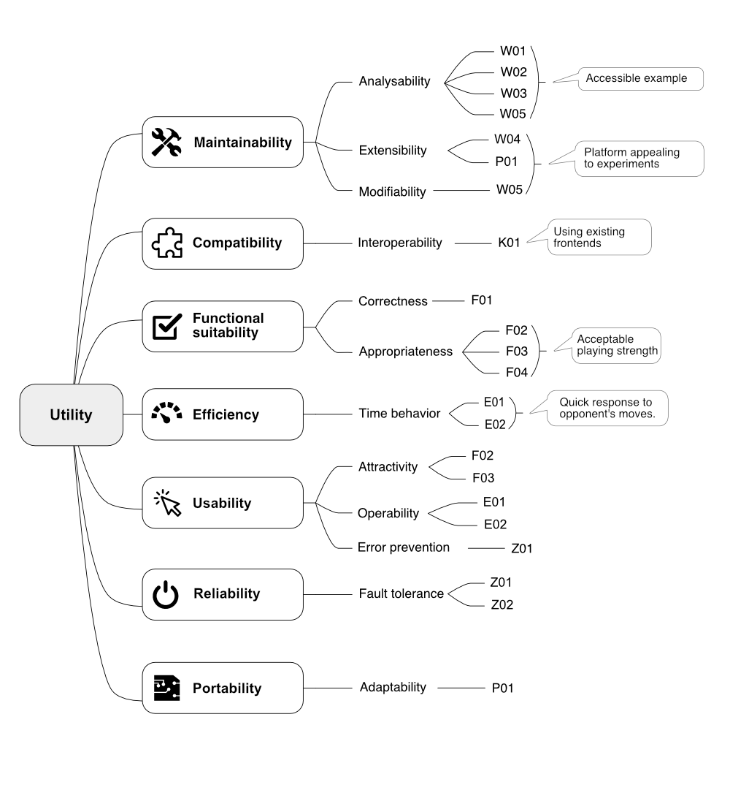

10.2 Quality Scenarios
The initial letters of the identifiers (IDs) of the scenarios in the following table each stand for the parent quality attribute (in German), E for efficiency, for instance. These identifiers are also used in the quality tree. The scenarios cannot always be clearly assigned to one characteristic. Therefore, they sometimes appear several times in the quality tree.
ID | Scenario
W01 | A person with basic knowledge of UML and chess looks for an introduction to the ChessProg architecture. He or she gets the idea of the solution strategy and the essential design within 15 minutes
W02 | An architect who wishes to apply arc42 searches for a concrete example for an arbitrary section of the template. He or she finds the relevant content immediately in the documentation.
W03 | An experienced Java developer searches for the implementation of a module described in the design. He or she finds it in the source code without detours or help from others.
W04 | A developer implements a new position evaluation. He or she integrates it into the existing strategies without modification and without compilation of existing source code.
W05 | A developer implements a piece-centric bitboard representation of the game situation. The effort (which includes replacing the existing, square-centric representation) is lower than one person week.
K01 | A user plans to use ChessProg with a frontend that supports a communication protocol that’s already implemented by the solution. The integration does not require any programming effort, the configuration with the front end is carried out and tested within 10 minutes.
F01 | In a game situation, the engine has one or more rule-compliant moves to choose from. It plays one of them.
F02 | A weak player is in a game against the engine. The player moves a piece to an unguarded position which is being attacked by the engine. The engine consequently takes the dropped piece.
F03 | Within a chess match, a knight fork to gain the queen or a rook arises for the engine. The engine gains the queen (or the rook) in exchange for the knight.
F04 | Within a chess match, a mate in two unfolds to the engine. The engine moves safely to win the game.
E01 | During the game, the engine responds to the move of the opponent with its own move within 5 seconds.
E02 | An engine integrated in a graphical frontend plays as black, and the human player begins. The engine responds within 10 seconds with its first move, and the user gets a message that the engine “thinks” within 5 seconds.
Z01 | During the game, the engine receives an invalid move. The engine rejects this move and allows the input of another move thereafter and plays on in an error-free way.
Z02 | The engine receives an illegal position to start the game. The engine recognizes the situation and quits the game.
P01 | A Java programmer plans to use a chess frontend that allows the integration of engines, but does not support any of the protocols implemented by ChessProg. The new protocol can be implemented without changing the existing code, and the engine can then be integrated as usual.

11 Risks

11.1 Risk: Connecting to the Frontend fails
There is no knowledge about connecting an engine to an existing chess frontend. Available open source engines are programmed in C and are delivered as executable programs (*.exe). Since ChessProg is developed in Java, they are of limited use as examples. Nothing is known in the project about chess communication protocols.
If it is not possible to make a working connection, the solution can not be used with existing frontends. This not only lacks an important feature, but also makes the solution as a whole, especially as a case study, untrustworthy.

Contingency Planning
A simple textual user interface could be implemented in order to interact with the engine. The implementation of a ChessProg specific graphical front end would be costly

Risk Mitigation
Through an early proof of concept, certainty is achieved as soon as possible here.

11.2 Risk: Implementation effort too high
There is no experience with chess programming. Simultaneously, the rules that are to be implemented completely are extensive and complicated. The different pieces move differently, and there are special rules such as stalemate and promotion. In the case of castling and en passant, the move history, and not only the current situation on the board, is relevant.
The programming of the algorithms is also non-trivial. For the connection of opening libraries and endgame databases, extensive research is required.
The implementation of ChessProg runs as a hobby alongside, within the spare time. It is unclear whether this is sufficient to present ambitious results within schedule.

Contingency Planning
If there is no runnable version for the conference sessions, a live demonstration could be omitted. The free evening talk could even be canceled completely (which could negatively affect the reputation).

Risk Mitigation
In order to reduce effort, the following rules are not implemented at first:
- 50 moves rule
- threefold repetition
Their absence has little consequence with respect to the playing strength, and consequence no consequence with respect to the correctness of the engine.
Connecting opening libraries and endgame databases has low priority and and takes a back seat at first.

11.3 Risk: Achieving the playing strength fails
The quality goals demand both an acceptable playing strength and a simple, accessible solution. In addition, there are requirements with respect to efficiency. It is uncertain whether the planned Java solution with an object-oriented domain model and simple move selection can achieve these competing goals.
The risk manifests itself through too bad playing strength, too long waiting times or both. This would be particularly unpleasant for live performances in lectures, as the solution is not perceived as such by the listeners (but as a toy).
It is unclear at what point a playing strength is considered to be unreasonably weak.

Contingency Planning
In conference talks, parts of the live demonstration could be omitted. If necessary, we could show games played before.

Risk Mitigation
Suitable scenarios concretize the quality goals. With the help of chess literature (chess problems to be precise) we develop test cases (unit testing), which specify what playing strength can be expected. Thus at least we detect early where the engine stands.

12 Glossary

Introduction
“The game of chess is played between two opponents who move their pieces on a square board called a ‘chessboard’.”
From the FIDE Laws of Chess
The following glossary contains English chess terms and terms from the world of computer chess. Some of them go beyond the vocabulary of infrequent or casual chess players.
See FIDE Laws of Chess or the Wikipedia glossary of chess for more information.
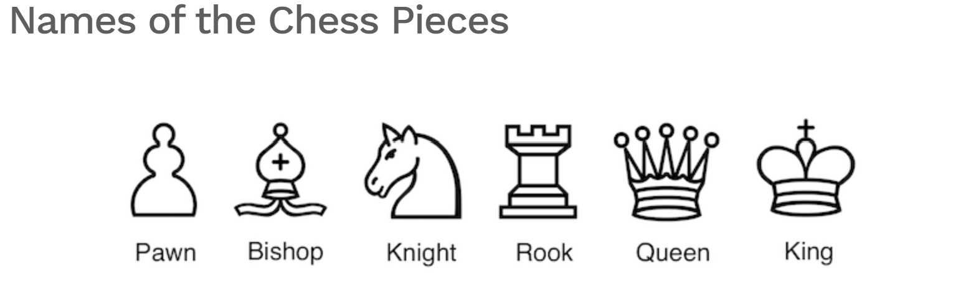

Chessboard Geometry
“The chessboard is composed of an 8 x 8 grid of 64 equal squares alternately light (the ‘white’ squares) and dark (the ‘black’ squares).”
From the FIDE Laws of Chess
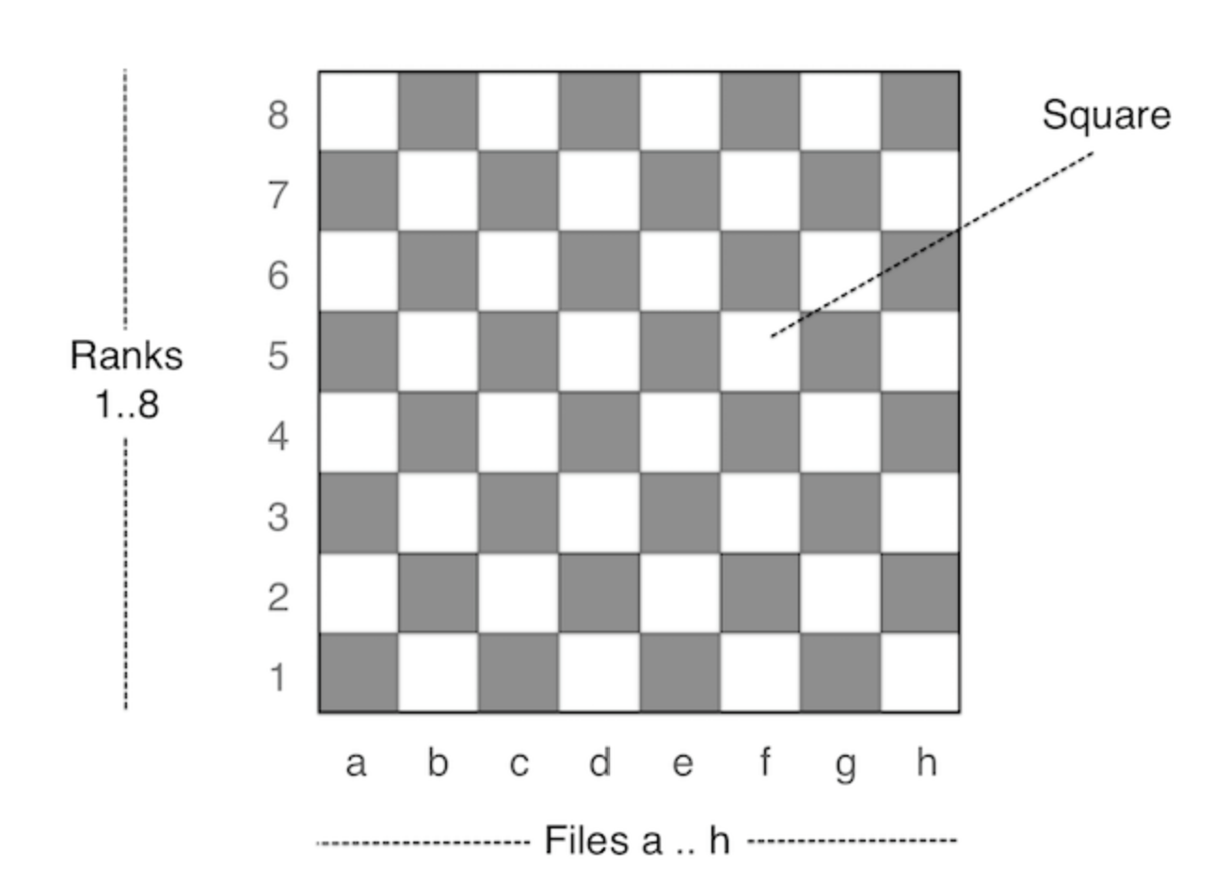

Terms

Term | Definition
50 move rule | A rule in chess, which states that a player can claim a draw after 50 moves whilst in the meantime no pawn has been moved and no piece has been taken.
Alpha-beta pruning | Significant improvement of the Minimax algorithm, in which parts of the search tree can be “cut off” without coming to a different resulting move.
Castling | A special move in chess where both the players’s king and one the rooks are moved. For castling, different conditions must be met.
Chess 960 | A chess variant developed by Bobby Fischer. The initial position is drawn from 960 possibilities. Also known as Fischer Random Chess.
to drop (a piece) | A beginner’s mistake in chess. A piece is dropped, if it is moved to a field attacked by the opponent and can be taken by him or her without risk or disadvantage.
Draw | A chess game which ends with no winner. There are various ways to end it with a draw, one of them is stalemate.
Half-move | Single action (move) of an individual player, unlike the sequence of a white and a black move which is counted as a move e.g. when numbering.
En passant | A special pawn move in chess. If a pawn moves on two squares and an opposing pawn could capture him, if he would advance only one square, the latter pawn may capture it en passant.
Endgame | The final stage of a chess game. It is characterised when only a few types of pieces are left on the board.
Engine | Part of a chess program which calculates the moves. Typically, an engine has no graphical user interface. Also known as ‘chess engine’.
FEN | Forsyth-Edwards Notation. Compact representation of a chess board position as a character string. Supported by many chess tools. Used in DokChess by unit and integration tests. Explanation see e.g. [Wikipedia] (https://en.wikipedia.org/wiki/Forsyth–Edwards_Notation)
FIDE | Fédération Internationale des Échecs, international chess organisation
Fork | A tactic in chess in which a piece attacks two (or more) of the opponent’s pieces simultaneously.
Knight fork | Particularly common form of a fork with a knight as attacking piece.
Mate | End of a chess game in which the king of the player to move is attacked and the player has no valid move left (i.e. can not escape the attack). The player has lost. Also known as ‘checkmate’.
Minimax algorithm | Algorithm to determine the best move under the consideration of all options of both players.
Opening | First stage of a chess game. Knowledge and best practices of the first moves in chess fill many books and large databases.
Polyglot Opening Book | Binary file format for opening libraries. Unlike many other formats for this purpose the documentation of it is freely accessible.
Promotion | A rule in chess which states that a pawn who reached the opponent’s base line is immediately converted into a queen, rook, bishop or knight.
Skewer | A tactic in chess in which a straight line passing piece stands on a rank, file or diagonal with two opponents pieces and forces the fore of the two pieces to move away.
Stalemate | End of a chess game in which the player to move does not have a valid move, but his or her king is not under attack. The game is considered a draw.
Threefold repetition | A rule in chess, which states that a player can claim a draw if the same position occurs at least three times.
WinBoard protocol | See XBoard protocol.
XBoard protocol | Text-based protocol for communication between chess frontends and engines. Also referred to as “WinBoard” or (more rarely) as “Chess Engine Communication Protocol”.

